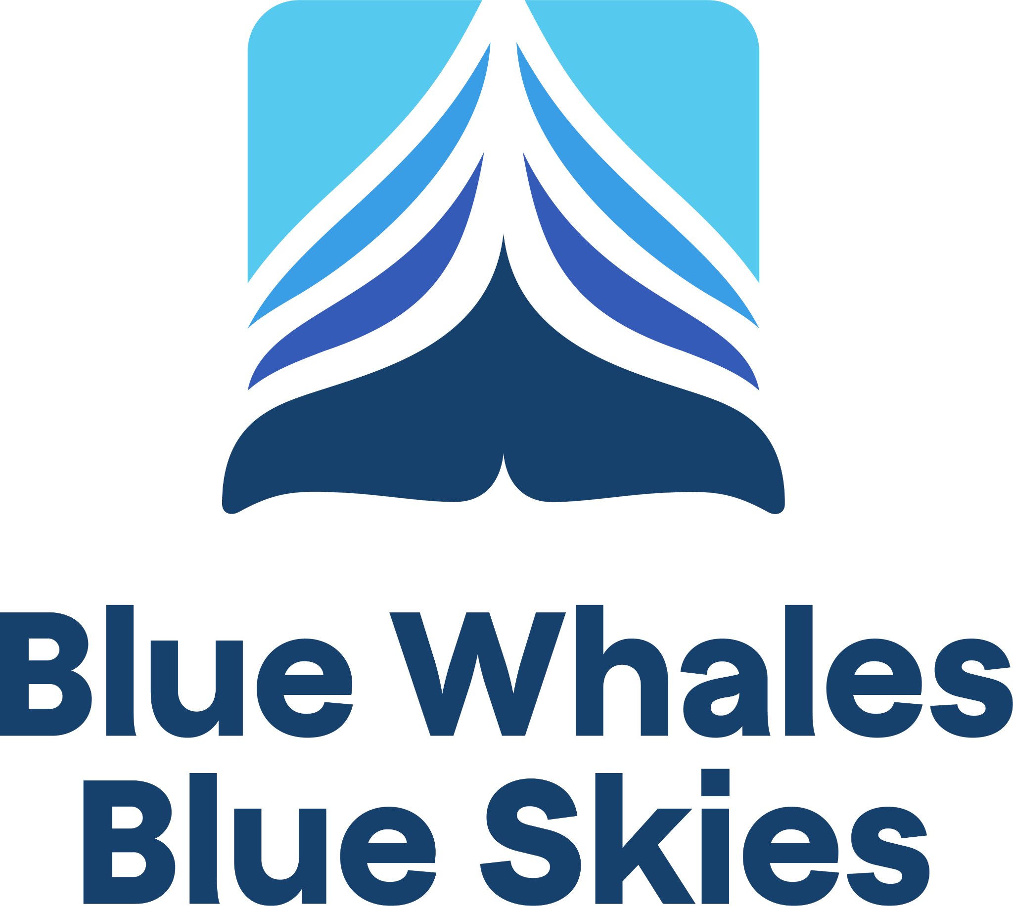

AMBASSADOR AGREEMENT

(Except as otherwise indicated, this is a non-binding Agreement to encourage and support Ambassadors who wish to promote more sustainable ocean shipping through reduced vessel speeds.)

[Company Name] (the “Ambassador”) enters into this Ambassador Agreement (the “Agreement”) as an ambassador of Protecting Blue Whales and Blue Skies (the “Program”). The Program is a voluntary Vessel Speed Reduction (“VSR”) effort encouraging ship operators to reduce their speeds in strategic areas (“VSR Zones”) within the United States Exclusive Economic Zone during specific periods (“VSR Season”) as set by the National Oceanic and Atmospheric Administration (NOAA). Speed reduction reduces the risk of ship strikes to endangered whales, air pollution, regional greenhouse gas emissions, and underwater noise. The Program is a unique collaboration between federal and local government agencies, foundations, and environmental nonprofits, including but not limited to the California Marine Sanctuary Foundation, Channel Islands, Chumash Heritage, Monterey Bay, Greater Farallones and Cordell Bank National Marine Sanctuaries, the Bay Area Air Quality Management District, Santa Barbara County, Ventura County, San Luis Obispo County Air Pollution Control Districts, and Monterey Bay Air Resources District (collectively, the “Program Sponsors,” which may change without notice). The Ambassador voluntarily agrees to participate in the Program under the terms and conditions set forth in this Agreement.

# Ambassador Roles and Responsibilities

During the term of this Agreement, the Ambassador agrees to:

* 1. If the Ambassador a) uses shipping lines (directly or indirectly via a logistics provider or freight forwarder) to import or export goods to or from California via ocean freight or b) provides logistics or freight forwarding services to other parties importing or exporting goods to or from California via ocean freight, provide the Program with a list of all shipping lines used for transporting such cargo to and/or from California ports (the “Ambassador Carriers”), which the Ambassador shall update annually during the term of this Agreement. The Ambassador Carriers must include at least one Participating Shipping Line (as defined below) for the Ambassador to be eligible for the Program.
     1. In addition to the names of the Ambassador Carriers, the Ambassador may provide the Program with a full list of shipments through VSR Zones both annually (at the end of the VSR Season) and at the VSR Season half-way mark (“Mid-Season”). If the Ambassador does so, it will be recognized through a tiered award system (described in Attachment A) based on the percentage of eligible shipments transported by Participating Shipping Lines (“Participating Shipping Line” is defined as a shipping line enrolled in the Program with at least 30% of its total distance traveled within VSR Zones being at 10 knots or less).
  2. If the Ambassador works within the shipping industry on goals aligned with the Program (e.g., air quality, marine conservation) and provides services to at least one Participating Shipping Line, then the Ambassador will be recognized at the Program’s base level as described in Attachment A.
  3. Provide the Ambassador’s preferred name and high-resolution digital logo(s) for use in the Program’s positive public recognition campaigns.
  4. Allow the Program, including the Program Sponsors, to use the Ambassador’s name, logo(s), and/or trademarks during the term of the Agreement for purposes consistent with the Program’s goals and objectives, including to promote and publicize the Program and to support positive public recognition campaigns highlighting the Program’s impact.
  5. If applicable, within 60 days after the date of this Agreement, distribute communications (emails or letters) to all Ambassador Carriers and, as applicable, logistics or freight forwarder partners to either congratulate them for being Participating Shipping Lines or to encourage their cooperation with and/or participation in the Program. The Program will provide example templates for such communications. The Ambassador will copy or forward all such communications to **info@bluewhalesblueskies.org**.
  6. To the best of its ability, highlight the Program in the Ambassador’s relevant communications, social media, sustainability reports, relevant publications, and website. The Ambassador agrees to inform **info@bluewhalesblueskies.org** of such communication activities related to the Program.

# Program Roles and Responsibilities

During the term of this Agreement, the Program agrees to:

* 1. Allow the Ambassador to use the Program’s name and logo on the Ambassador’s website, communications, social media, and press related to the Ambassador’s sustainability efforts.
  2. Provide annually to the Ambassador a breakdown of the environmental benefits, including reductions in regional emissions, air pollution, ship strike risk and noise pollution, resulting from the Participating Shipping Lines’ participation in the Program.
  3. Feature the Ambassador on the Program’s website, social media, and other public relations efforts.
  4. Provide further recognition of the Ambassador based on the applicable Award Tier described in Attachment A.
  5. Provide the Ambassador with updated lists of Participating Shipping Lines and their respective tier status (as outlined in Attachment B) following the close of each VSR Season and at the Mid-Season.

# Conditions

* 1. Changes: The Program, including the incentives and requirements for participating in the Program and all other aspects of the Program, may be amended, modified, or terminated at any time by the Program Sponsors. Further, the Program Sponsors may amend this Agreement at any time. The Program Sponsors will notify the Ambassador of any relevant changes to the Program or to this Agreement, which shall become effective immediately. The Ambassador shall be deemed to have accepted such changes unless it provides the Program Sponsors with written notice to the contrary within 20 days after its receipt of the notice of such changes and requests termination of this Agreement.
  2. Term and Termination: This Agreement shall remain in effect until it is terminated by either party in accordance with its terms. Either party may terminate this Agreement without cause by providing 30 days’ written notice to the other party. Upon termination, both parties will, as soon as reasonably practicable, stop using the other party’s name and logo and cease public affiliation through means such as websites, social media platforms, and similar forms of communication.
  3. Assumption of Risk: To the extent permitted by law, the Ambassador shall defend, indemnify, and hold harmless the Program, the Program Sponsors, and their respective officers, employees, agents, or representatives (collectively, the “Program Parties”) from and against any and all claims, suits, or actions arising out of, related to, or otherwise in connection with the Ambassador’s participation in the Program and performance under this Agreement, except to the extent it is caused by the gross negligence or willful misconduct of a Program Party. This Section III.3 is binding and shall survive the termination of this Agreement.
  4. Intellectual Property:
     1. All copyrights, trademarks, and any other intellectual property (“IP”) disclosed or provided in connection with this Agreement shall remain the property of the disclosing party.
     2. Any IP created in connection with this Agreement is the property of the creator. Use of the other party’s IP must cease as soon as reasonably practicable upon termination of this Agreement, unless otherwise explicitly provided for in this Agreement or agreed to at the time the IP is created.
     3. The Ambassador may not use or share IP owned by the Program or any Program Sponsor without formal written consent by the Program or relevant Program Sponsor. All IP protections are binding and shall survive the termination of this Agreement.
  5. Miscellaneous: This Agreement does not create any legal, association, partnership, joint venture, principal/agent, employer/employee, or master/servant relationship between the parties. This Agreement shall be governed by and construed in accordance with the internal laws of the state of California without giving effect to any choice or conflict of law provision or rule (whether of the state of California or any other jurisdiction) that would cause the application of laws of any jurisdiction other than those of the state of California. This Agreement may be signed and delivered by means of electronic format or signature (including e-mail, “pdf,” “tif,” “jpg,” DocuSign and Adobe Sign). For more information on the Program, visit www.bluewhalesblueskies.org.

************

IN WITNESS WHEREOF, the Ambassador has caused this Agreement to be duly executed and delivered by its authorized representative.

AMBASSADOR:

By:

Name:

Title:

Address:

Email:

Date:

Attachment A:

**Ambassador Award Tiers - Ambassador Program**

|  |  |  |
| --- | --- | --- |
| **TIER** | **Requirements**  (% Eligible Shipments on Participating Shipping Lines*) | **Recognition Benefits†** |
| **Base Level** | **Ship with at least one Participating Shipping Line** | Logo on website, participation noted in Program communications (various media, advertising, news releases,  announcements) |
| **Blue Sky** | **50-69%** | Base level benefits plus tier status highlighted in Program communications |
| **Gold** | **70-89%** | Base level benefits plus tier status highlighted in Program communications |
| **Sapphire** | **90-100%** | Base level benefits plus tier status highlighted in Program communications; **Annual Whale Tail** Award |
| **Sapphire Plus** | Exclusively ship with Sapphire rated Participating Shipping Lines | Base level benefits plus tier status highlighted in Program communications; **Annual Whale Tail** Award |

“*Participating Shipping Line(s)*” defined as an enrolled shipping line with at least 30% of its total distance traveled within Program VSR Zones being at 10 knots or less.

†The recognition described herein is a minimum, with additional activities possible (including, for example, award ceremonies, mention, or invitation to participate in articles, press releases, presentations, or other similar activities).

Attachment B:

**Participating Shipping Line Award Tiers**

|  |  |  |
| --- | --- | --- |
| **TIER** | **Requirements:** (% Distance Traveled in VSR Zones at 10 knots or less) | **Recognition†** |
| **Base Level** | **30%** | Logo on website, participation noted in Program communications (various media, advertising, news releases, announcements) |
| **Blue Sky** | **50-69%** | Logo on website, participation noted in Program communications; tier status highlighted |
| **Gold** | **70-89%** | Logo on website, participation noted in Program communications; tier status highlighted |
| **Sapphire** | **90-100%** | Logo on website, participation noted in Program communications; tier status highlighted; **Annual Whale Tail** Award; |